Mohannad Zahra
1. Developer Information
- Assigned Developer: Mohannad Zahra
- Current Status: In Progress
2. Target Scope
- Target Retailer: [e.g., B.TECH, Sigma Computer, Amazon Egypt]
- Broad Category: [e.g., PC Components, Mobile Phones]
- Specific Items Targeted: [e.g., RTX 40-series GPUs, iPhones, Samsung Galaxy S-series]
- Volume: [Roughly how many unique items does this script pull per run? e.g., ~150 items]
3. Data Extraction Schema Mark with an 'X' which data points your script is successfully and consistently extracting:
- [ ] Scrape Timestamp
- [ ] Product Title (Raw)
- [ ] Current Price
- [ ] Discounts label
- [ ] Original Price (if discounted)
- [ ] Stock Availability Status
- [ ] Product URL
- Extra Fields: [List any other data you are pulling, e.g., Shipping cost, SKU number, Reviews]
4. Technical Stack & Health
- Libraries Used: [e.g., BeautifulSoup, Selenium, Scrapy, Playwright]
- Anti-Bot Strategy: [Are you using time.sleep(), rotated headers, or proxies?]
- Execution Time: [How long does one full scrape cycle take? e.g., 12 minutes]
- Cycle Time: [interval time between each full scrape cycle? E.g., 6 hours]
- Known Issues: [Are you hitting CAPTCHAs, 403 Forbidden errors, or dynamic JavaScript loading issues?]
5. Data Output Proof
- Output Format: [e.g., CSV, JSON, Pandas DataFrame]
- Sample Data: [Paste 1 or 2 lines of the actual raw data your script outputs so we can check the formatting]

Abdelrhman Wael

1. Developer Information
- Assigned Developer: Abdelrhaman wael
- Current Status: Functional (Successfully generated 3,093 product records)

2. Target Scope
- Target Retailer: 2B Egypt (2b.com.eg)
- Broad Category: Electronics & Hardware (Mobiles, Laptops, Gaming, Smart Home, Appliances)
- Specific Items Targeted: Full inventory across 17 mapped categories (PC Components, TVs, etc.)
- Volume: ~3,090 unique items per full scrape cycle.

3. Data Extraction Schema
Marked with 'X' for successfully and consistently extracted data points:
- [X] Scrape Timestamp
- [X] Product Title (Raw)
- [X] Current Price
- [X] Discounts label (Calculated as discount_pct)
- [X] Original Price (if discounted)
- [X] Stock Availability Status (Extracted dynamically via DOM specs)
- [X] Product URL
- Extra Fields: Brand, Numeric Price, Deal Status (is_deal), Media URLs (Primary/Gallery), Regex-Extracted Specs (CPU, RAM, GPU, Storage, Resolution, OS, etc.), and Dynamic Table Specs (prefixed with spec_).

4. Technical Stack & Health
- Libraries Used: Playwright (async_playwright), Pandas, Asyncio, Re (Regex), Python Logging.
- Anti-Bot Strategy: Randomized User-Agents; randomized polite delays (1.2s – 3.5s); blocking heavy media payloads (images/fonts) during pagination; automated safe_goto retry mechanism.
- Execution Time: Approximately 1 to 2 hours for a full cycle (depending on network/concurrency).
- Cycle Time: N/A (Currently operating as a manual/monolithic one-off process).
- Known Issues: High dependency on site leniency for deep-tab scraping; vulnerable to Magento layout changes in #product-attribute-specs-table.

5. Data Output Proof
- Output Format: Multi-Sheet Excel (categorized).
- Sample Data: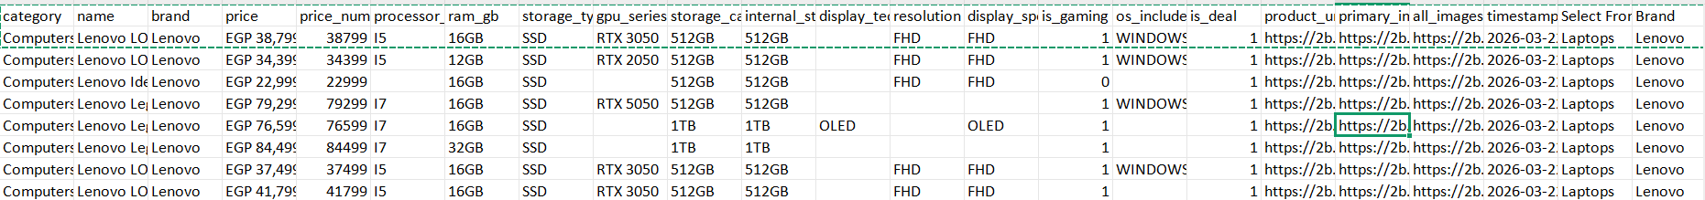

Mohammed Hessen
1. Developer Information
- Assigned Developer: Mohamed hussien
- Current Status: [Functional / Broken / In Progress]
2. Target Scope
- Target Retailer: Noon Egypt, jumia
- Broad Category: laptops and it's accessories and things
- Specific Items Targeted: Lenovo laptops only ??
- Volume: all items in the page
3. Data Extraction Schema Mark with an 'X' which data points your script is successfully and consistently extracting:
- [X] Scrape Timestamp (added manual)
- [X] Product Title (Raw)
- [X] Current Price
- [X] Product URL
- [X] Avg rating
- [X] No. Of rates
- [X] E-commerce platform
- [ ] Discounts label
- [ ] Original Price (if discounted)
- [ ] Stock Availability Status
4. Technical Stack & Health
- Libraries Used: web extension
- Anti-Bot Strategy: no need for that cause it's mostly manual
- Execution Time: 1 page on avg 1 to 2 minutes
- Cycle Time: every 12 hours
- Known Issues: sometimes it failed to scrap the price column at a certain page
5. Data Output Proof
- Output Format: csv
- Sample Data:
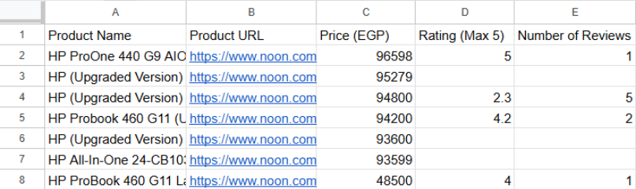

Adel Morad
1. Developer Information
- Assigned Developer: [Adel Morad]
- Current Status: [Functional (All categories: Laptops, Audio, TVs, and PlayStation are now working correctly)]
2. Target Scope
- Target Retailer: Dream2000 (Egypt)
- Broad Category: [Consumer Electronics & Gaming]
- Specific Items Targeted: [Laptops, Mobile Phones, Audio Accessories, TVs, and PlayStation Consoles/Games]
- Volume: [882 unique items successfully extracted in a single full execution across 5 categories]
3. Data Extraction Schema Mark with an 'X' which data points your script is successfully and consistently extracting:
- [X] Scrape Timestamp
- [X] Product Title (Raw)
- [X] Current Price
- [ ] Discounts label
- [X] Original Price (if discounted)
- [X] Stock Availability Status
- [X] Product URL
- Extra Fields: [Category Name and details , Image URL]
4. Technical Stack & Health
- Libraries Used: [requests, BeautifulSoup4, csv, time, os]
- Anti-Bot Strategy: [custom User-Agent headers, Accept-Language headers (to force English UI), and a 2-second time.sleep() politeness delay between pages]
- Execution Time: [~20–30 seconds per category (for 10 pages)]
- Cycle Time: [Manual execution (can be scheduled via Task Scheduler or Cron)]
- Known Issues: [Previously encountered 404 errors due to incorrect URL parameter syntax (? vs &), now resolved with conditional logic.]
5. Data Output Proof
- Output Format: [CSV (Dream2000.csv) with UTF-8-BOM encoding for Excel compatibility]
- Sample Data: 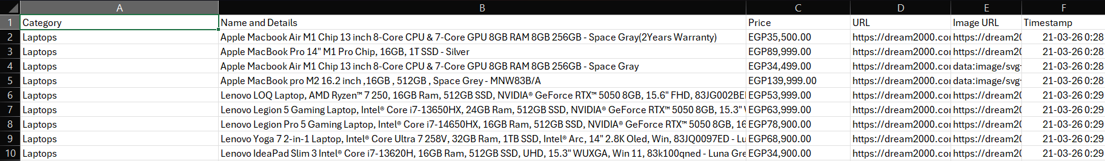

Mohammed Rasheek
1. Developer Information
- Assigned Developer: Mohamed Rasheek
- Current Status: Functional
2. Target Scope
- Target Retailer: Sigma
- Broad Category: Laptop
- Specific Items Targeted: Dell Laptops
- Volume: 50
3. Data Extraction Schema Mark with an 'X' which data points your script is successfully and consistently extracting:
- [ ] Scrape Timestamp
- [X] Product Title (Raw)
- [X] Current Price
- [ ] Discounts label
- [X] Original Price (if discounted)
- [X] Stock Availability Status
- [X] Product URL
- Extra Fields: [List any other data you are pulling, e.g., Shipping cost, SKU number, Reviews]
4. Technical Stack & Health
- Libraries Used: BeautifulSoup
- Anti-Bot Strategy: randomized time.sleep()
- Execution Time: under 10 minutes
- Cycle Time: 12 hours
- Known Issues: pagination failing
5. Data Output Proof
- Output Format: CSV
- Sample Data:
